Analysis Of Rainfall In India Using Tableau

**Project Description:**

Rainfall forecasting is very important because heavy and irregular rainfall can have many impacts like destruction of crops and farms, damage of property so a better forecasting model is essential for an early warning that can minimize risks to life and property and also managing the agricultural farms in better way. This study aims to determine trends in annual and seasonal rainfall and rainy days over different river basins across India.

The project reviews, rainfalls in India visualization in Tableau environment. The aim is to show how to extract meaningful data from the raw data and visualize it. The rainfall pattern in the States/Union Territories of India was successfully visualised.

Project Objectives

**By the end of this project you will:**

* know fundamental concepts and can work on Tableau.
* gain a broad understanding of plotting different graphs.
* Able to create meaningful dashboards

Project Flow

* Users can create multiple analysis graphs/charts.
* Using the analysed chart creation of Dashboard is done.
* Saving and Visualizing the final dashboard in the personal Tableau public profile.

To accomplish this, we have to complete all the activities and tasks listed below

* Working with the Dataset
  + Understand the Dataset
  + Loading the Dataset
* Visualizations of Rainfalls in India (1901-2015)
  + Problem Statement 1: Annual average Rainfall analysis by states
  + Problem Statement 2: Find the Rainfall Season(Average Seasonal Rainfall)
  + Problem Statement 3: Top 10 States which is having Heavy Rainfall
  + Problem Statement 4: Seasonal wise Rainfall occurred in States

**Project Demonstration:**

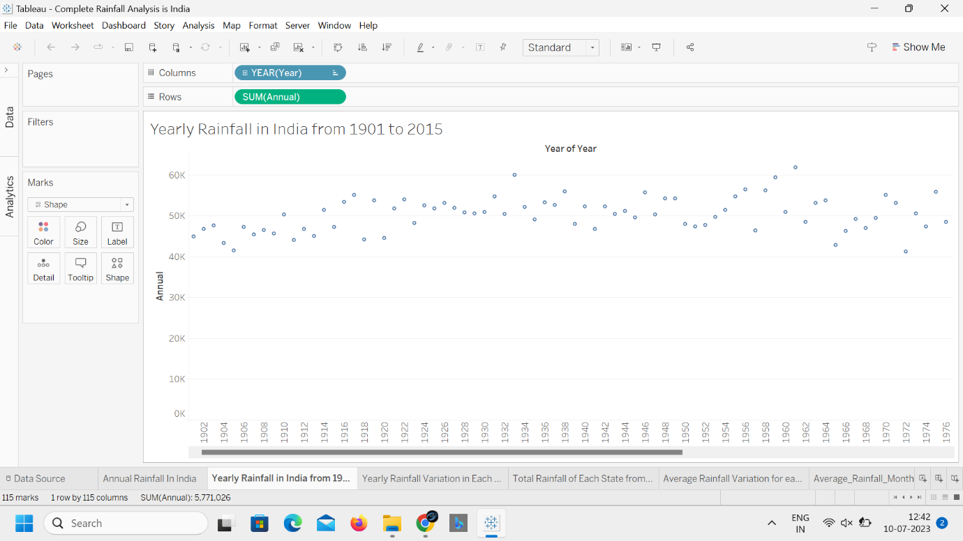

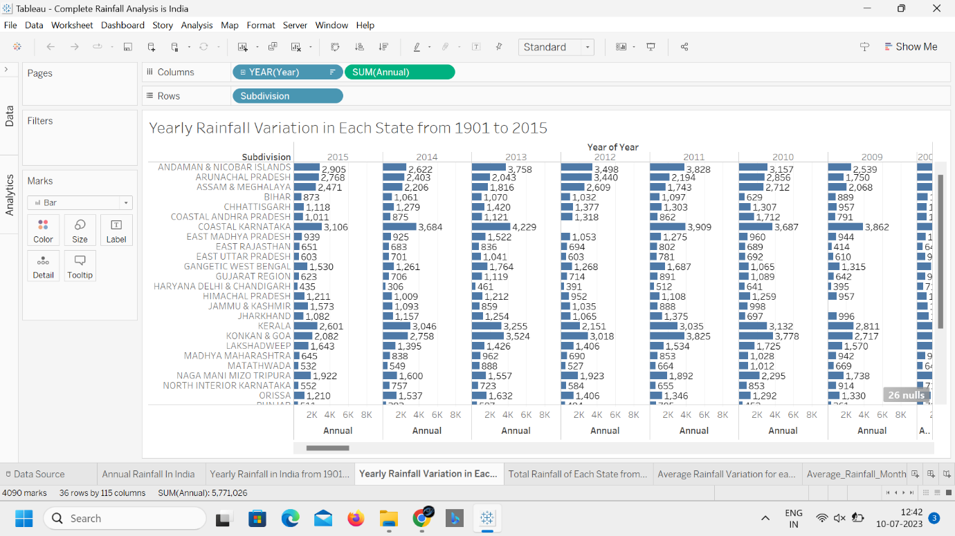

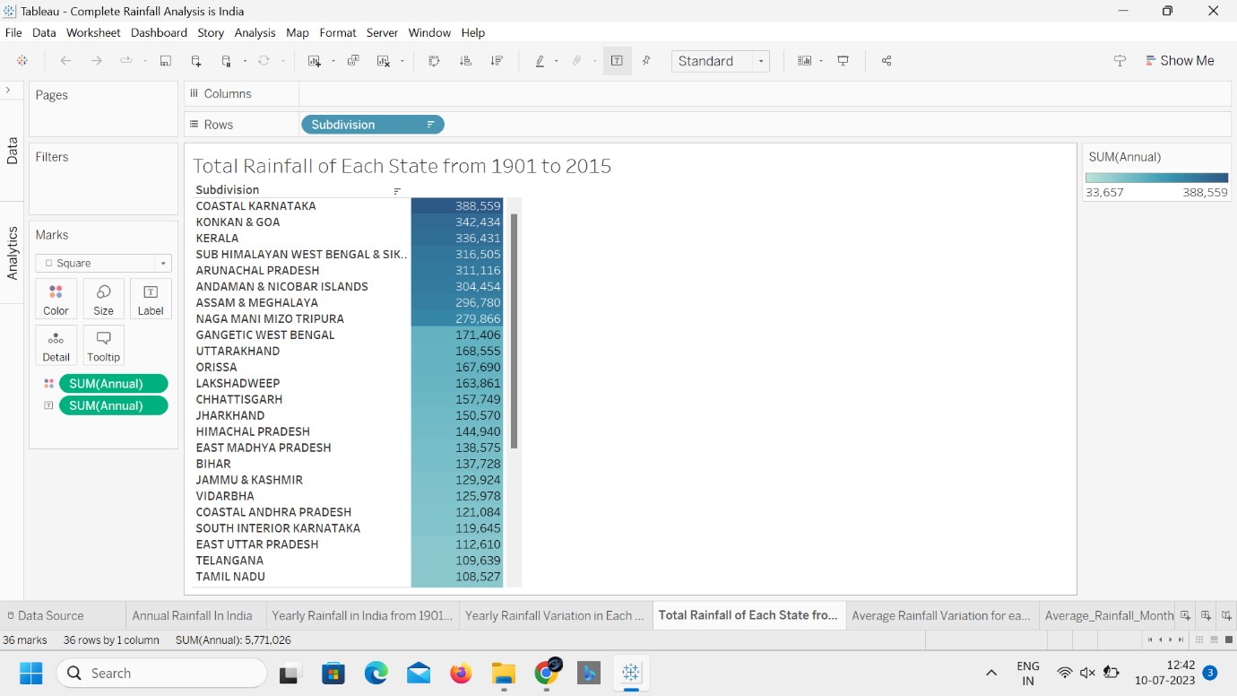

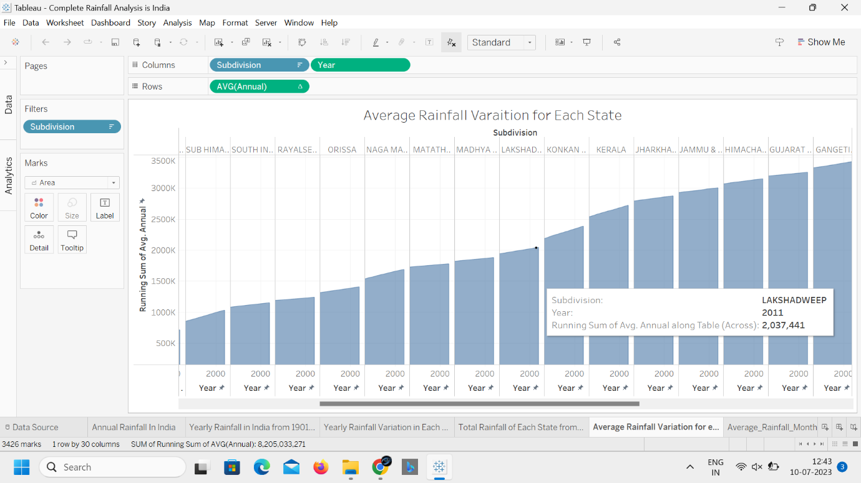

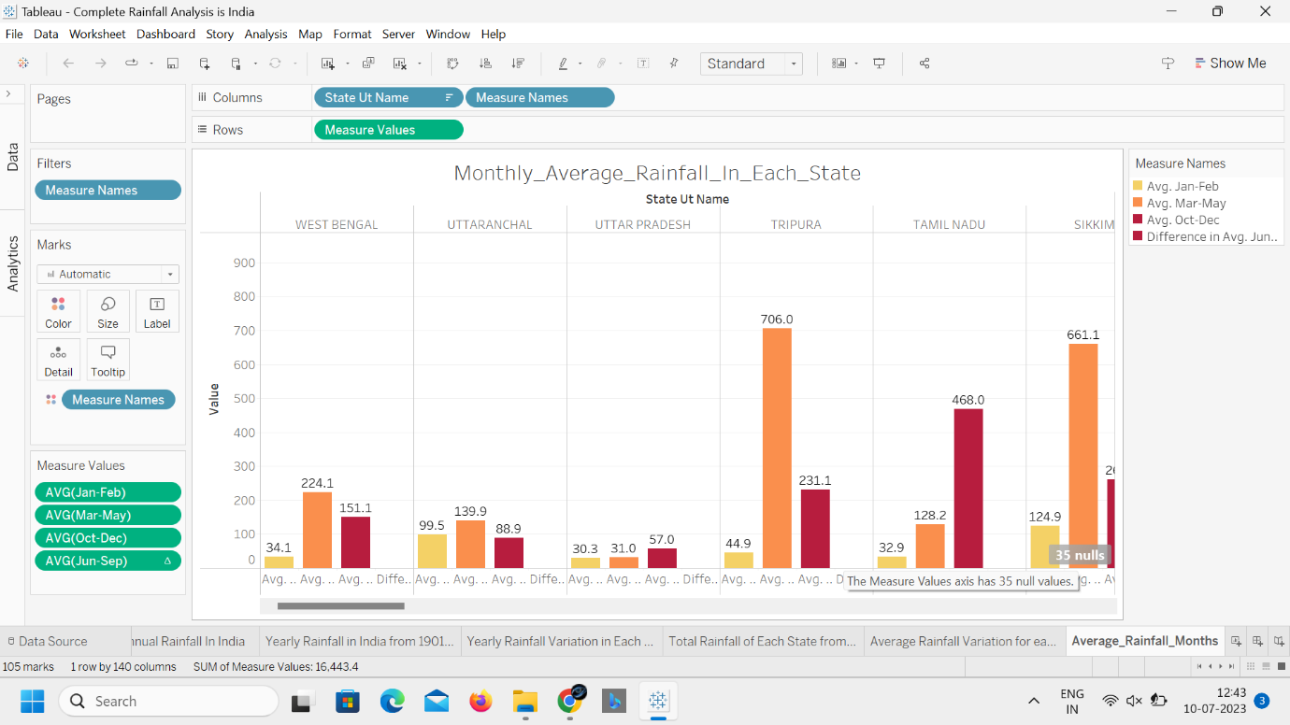

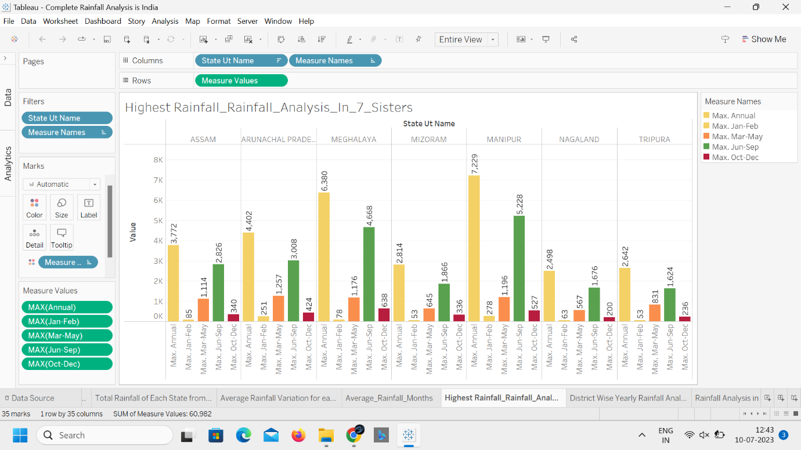

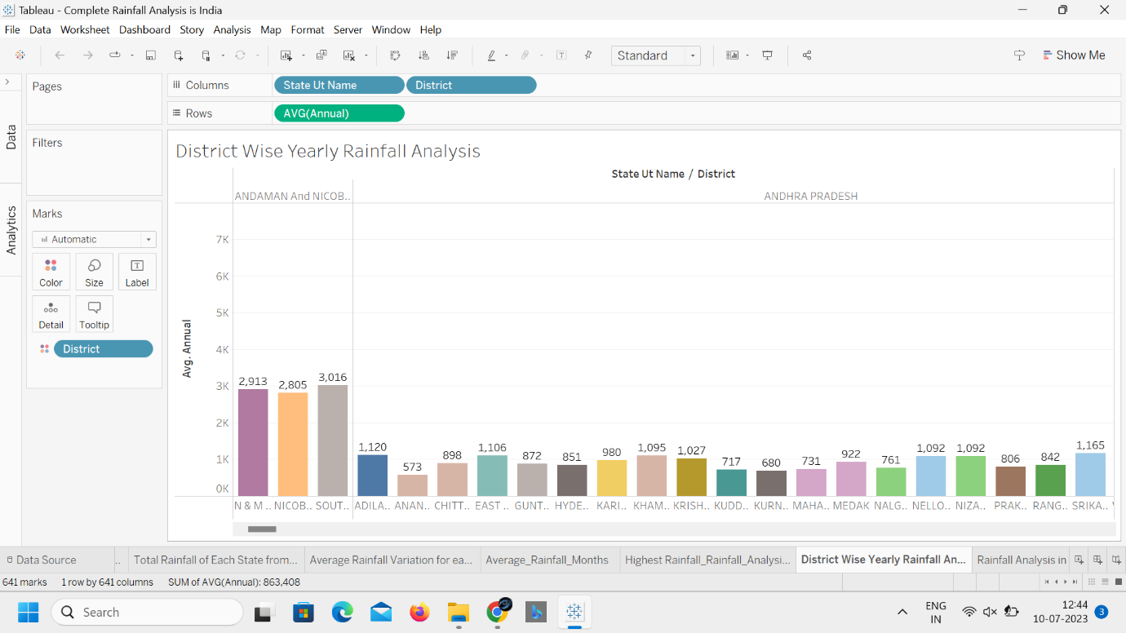

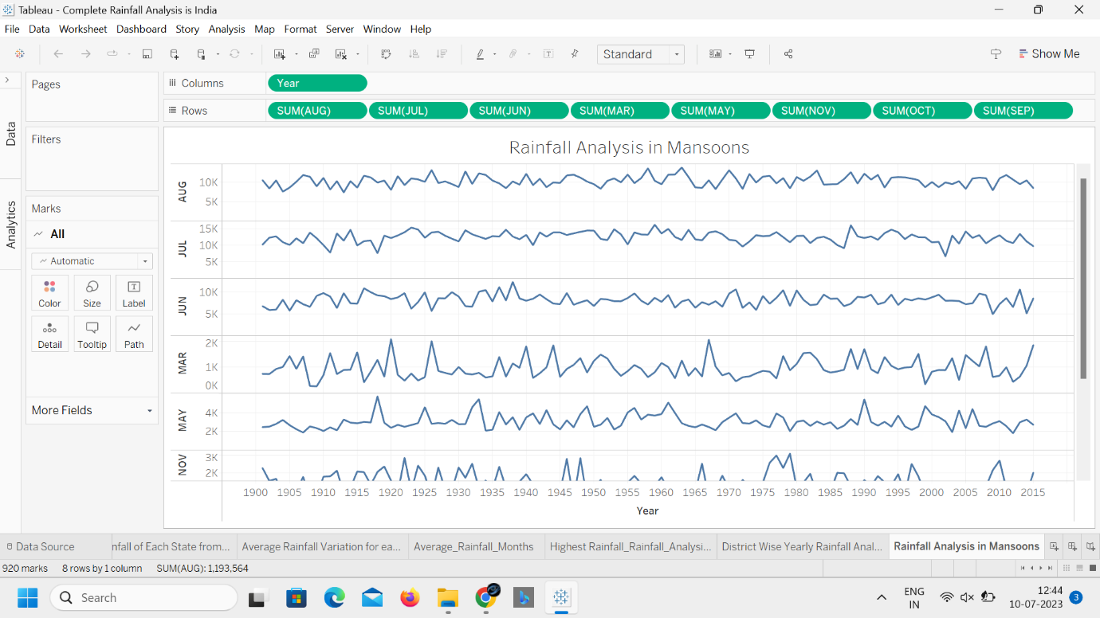

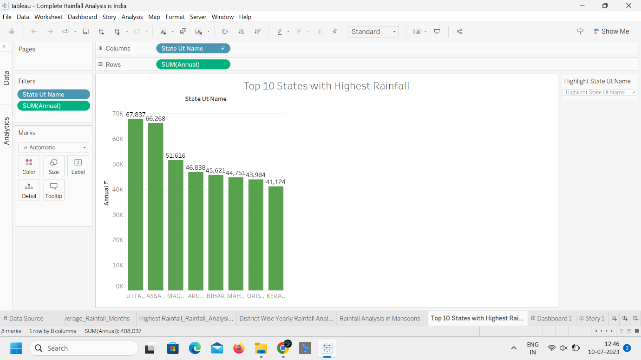

DashBoard

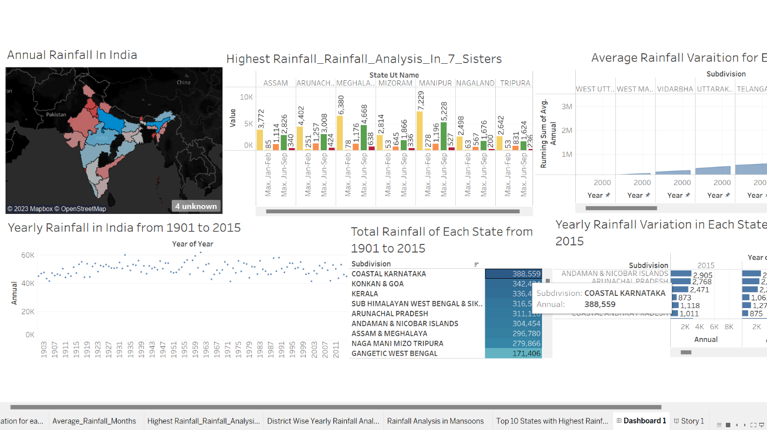

Team Members: -

From VIT-AP University

Sree Venkateswarlu (20BEC7002)

Surya Teja (20BCI7102)

Vidya Sri (20BCI7024)

Ravali (20BCI7122)